The Two Numbers

Ram and Mohan are two brothers. They are not good in maths. So their father decided to give some assignment as a game so that they can enjoy as well as they can learn the concept of number systems. So he gave two numbers to them. One is the sum of two numbers, x and y, and another is the product of same two numbers. Help them to write a code to find x and y.

Note:

The two numbers should be printed in ascending order.

Input format

The input contains two integers in the same line separated by space, that denotes the sum of x and y and the product of x and y, respectively.

Output format:

The output consists of two numbers separated by space which corresponds to x and y in ascending order.

Sample Input 1:

5 6

Sample Output 1:

2 3

Sample Input 2:

15 50

Sample Output 2:

5 10

Amar's team is assigned with a project that deals with the digital signals. He is aware that the digital signals will be represented as arrays. He wants to test his team with respect to their strength in arrays.As part of the skill testing, the task is as follows.

You are given an array of integers of size N.

Consider all its contiguous subarrays of length k and find the maximum sum.

Do this for all k from 1 to the length of the input array.

Write a program to evaluate the task done by the kids.

Input format:

The first line contains a single integer denotes the size of the array, N.

The second line contains N-space separated integer that corresponds to the values of the array.

Output format:

The output consists of N-space separated integer values of the result array.

Sample Input 1:

5

-1 2 1 3 -2

Sample Output 1:

3 4 6 5 3

Explanation:

For inputArray = [-1, 2, 1, 3, -2], the output should be [3, 2, 1, 0, 0].

The contiguous subarray

of K = 1, each subarray will have 1 element. The sub-array with maximum sum is [3]. So result[0] = 3.

of K = 2, each subarray will have 2 elements. The sub-array with maximum sum is [1,3]. So result[1] = 4.

of K = 3, each subarray will have 3 elements. The sub-array with maximum sum is [2,1,3]. So result[2] = 6.

of K = 4, each subarray will have 4 elements. The sub-array with maximum sum is [-1,2,1,3]. So result[1] = 5.

of K = 5, each subarray will have 5 elements. The sub-array with maximum sum is [-1,2,1,3,-2]. So result[1] = 3.

So the result array is [3, 4, 6, 5, 3].

Sample Input 2:

5

2 3 2 -2 3

Sample Output 2:

3 5 7 6 8

In summer vacation time, the students of ABC school went for a team outing. One day the instructor decided to find one funny game so that student can enjoy. So he told them to take one integer N and arrange the digits of the integer in incremental order from right to left. Help students by writing a code.

Input format:

The first line contains a single integer that denotes the given number, N.

Output format:

The output is an integer in which the digits of N are arranged in incremental order from right to left.

Sample input 1:

231

Sample output 1:

321

The Team Leader of Testing team of XYZ company decided to assess the team members by organising a programming event. So he gave the team a task.

The task is given an array of size N, find the number of distinct elements in the array and print them in ascending order. Those members who answer, will get some reward.

Write a program to help the Team Leader to evaluate the solutions of the team members.

Input format:

The first line contains a single integer that denotes the size of the array, N.

The second line contains N space separated integer values of the array.

Output format:

The first line is an integer that denotes the number of the distinct elements i nthe array.

The second line is a series of integers seperated by space that denotes the distinct elements.

Sample Input 1:

5

1 2 1 2 1

Sample Output 1:

2

1 2

Sample Input 2:

5

145 25 21 25 36

Sample Output 2:

4

21 25 36 145

As part of the picnic events, the families from ABC apartment plan to organise some games for their kids so that they can learn some thing during leisure time also. The task is as follows.

Given a string S, find the string which has only the distinct character in S. The characters should be presented in the descending order of its occurrence. If the occurrence count of two characters is same, then the order for those two characters should be the same as it is in the input string.

Input Format:

The input is a string that denotes the S.

Note: The String is case-sensitive.

Output Format:

The output is a string that denotes the modified string.

Sample Input 1:

HelloWorld

Sample Output 1:

loHeWrd

Sample Input 2:

Entertainment

Sample Output 2:

nteEraim

Anuska has created a robot that will take instructions and work accordingly. Due to budget problem, she has set the memory low. To overcome that, she has to encode the instruction. Given the instruction S, count the consecutive characters and each character will be folowed by its frequency.

For example, if the instruction is "aaaabb", the encoded instruction is "a4b2".

Note:If the frequency is one, the count need not be printed.

Input format:

The first input is a string that denotes the instruction, S.

Output format

Output is a string that denotes the encoded string.

Sample input 1:

aaaabb

Sample output 1:

a4b2

Sample input 2:

sggvvvgss

Sample output 2:

sg2v3gs2

Q1: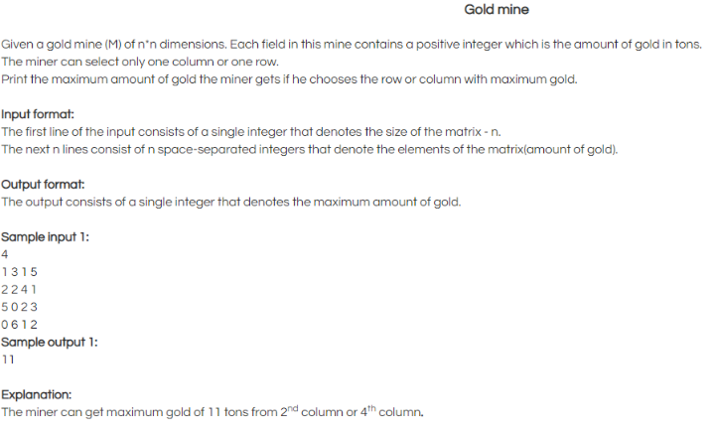

Q2: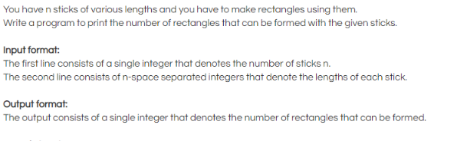

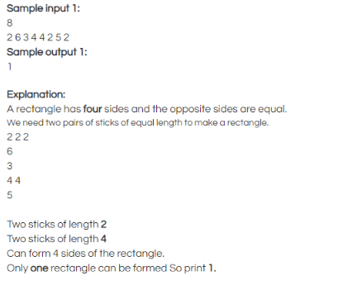

Q3: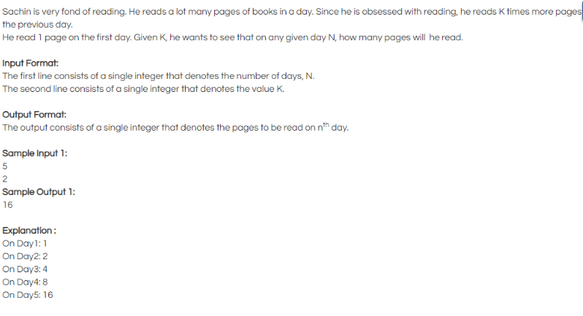

Q4: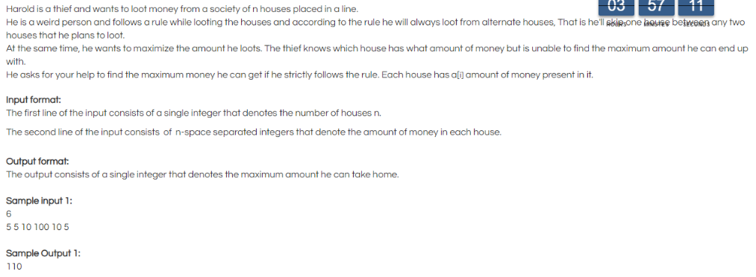

Q5: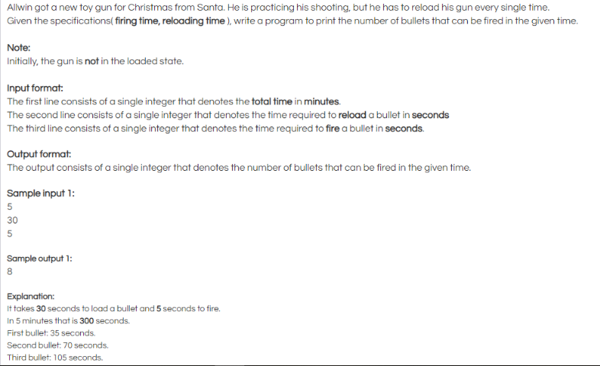

Q6: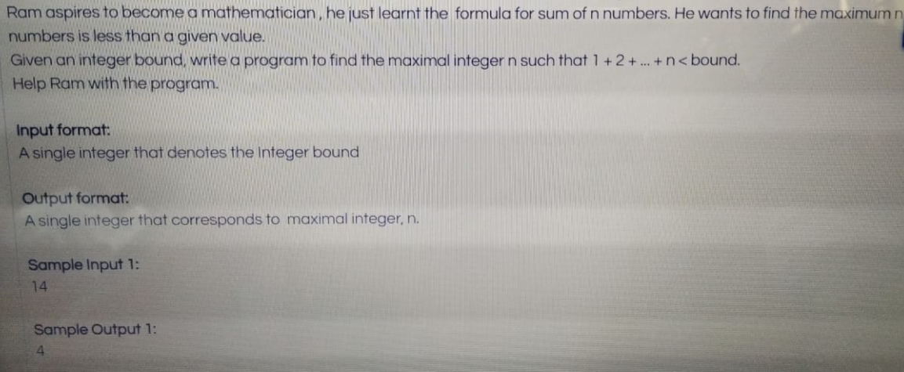

Q7: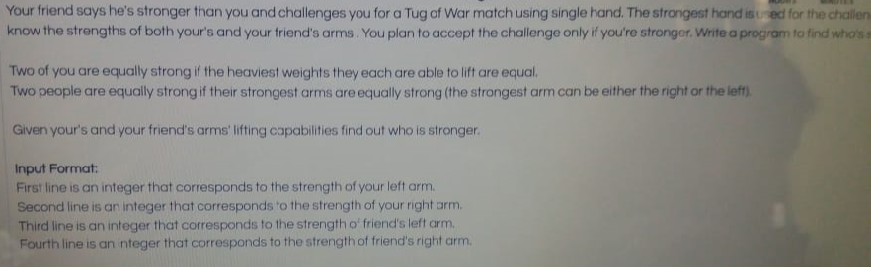

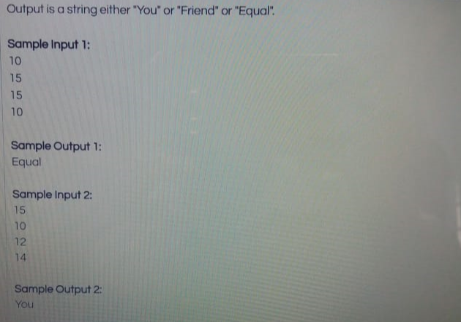

Q8:

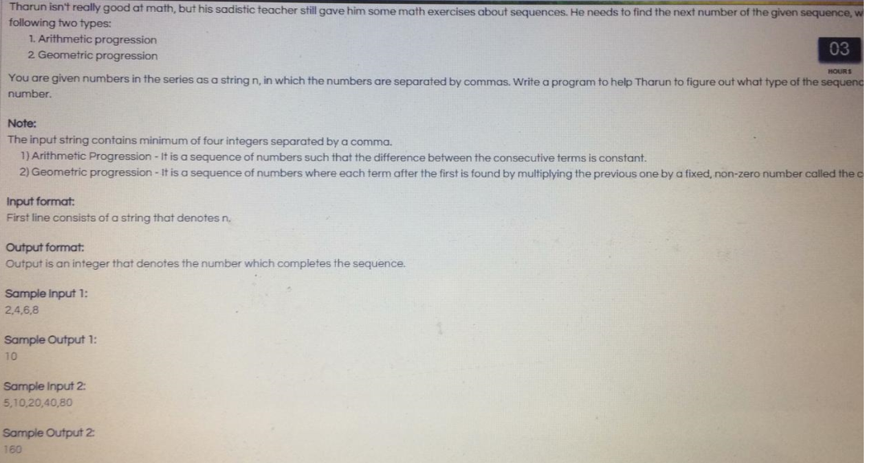

Q9.

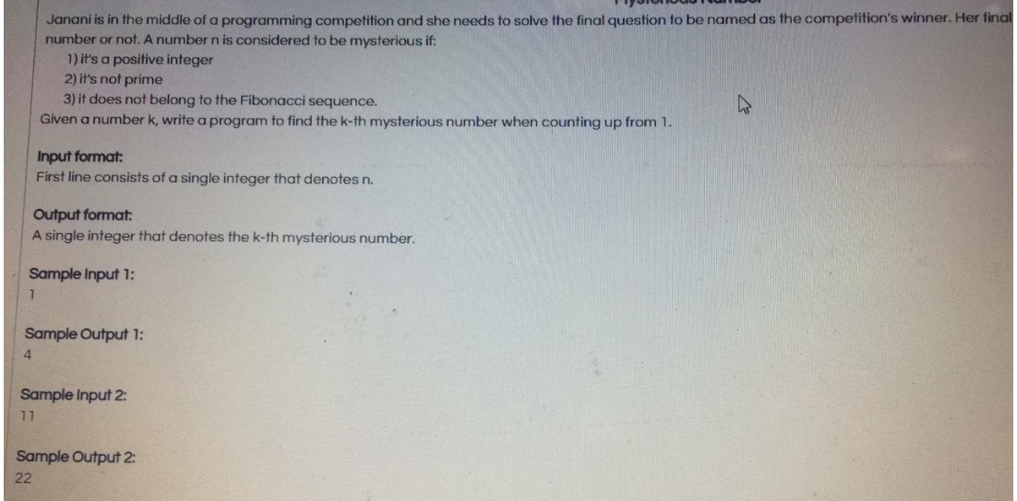

Q10.

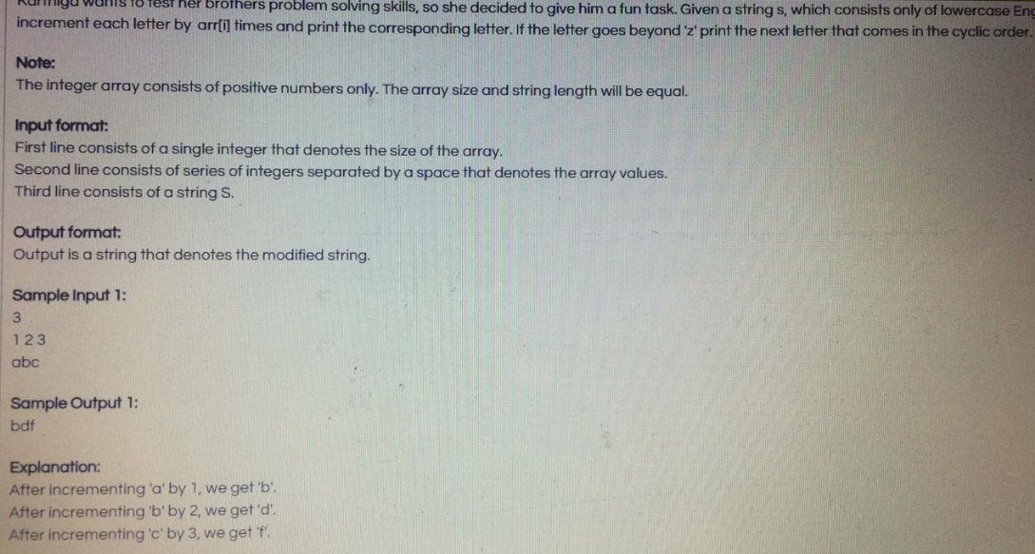

Q11.

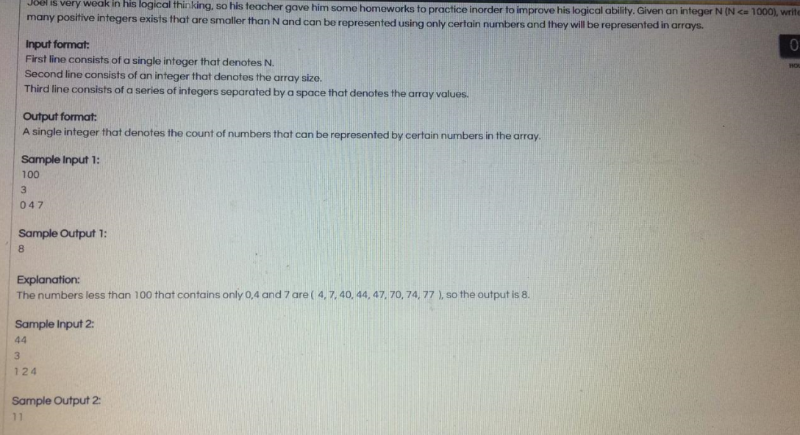

Q12.

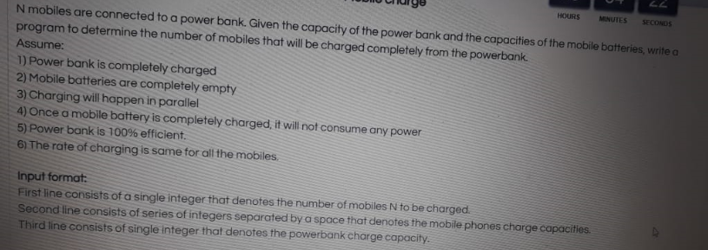

Input:

5

800 400 200 100 2000

1600

Ouput:

3

